One/two Stage Unlocking Control Function – CGEA1.3

Functional Description

This STSS handles setting of the One/two Stage Unlocking feature for vehicles that have a high-end display. The one/two stage unlocking setting is a CAN message that is output by the IC as a command to the BCM to change or request the current status of the one/two stage unlocking feature.
The feature allows the user to unlock only the driver door or all doors with a single FOB button press. Using the Message Center Switches and Display, the customer can select either one stage or two stage unlocking.

Starting in MY2019 with U625/U611 the Settings are migrating from the cluster to Center stack. This STSS supports displaying settings in the cluster or configuring the cluster settings off if they are displayed in the Center stack.

There is a unique HMI menu required only for Commercial Transit vehicles. This is controlled via a Transit specific DE09 EOL configuration bit.

Unlocking Control Function is displayed only in the Message Center while it is in the appropriate SETUP display. See Message Center X Display Y Button Interface Section, where X and Y are appropriate values in this document for details on when this display is active.

Interfaces

Interface Context Diagram (I/O Block Diagram)
Figure 1: One/Two Stage unlocking Function Context Diagram

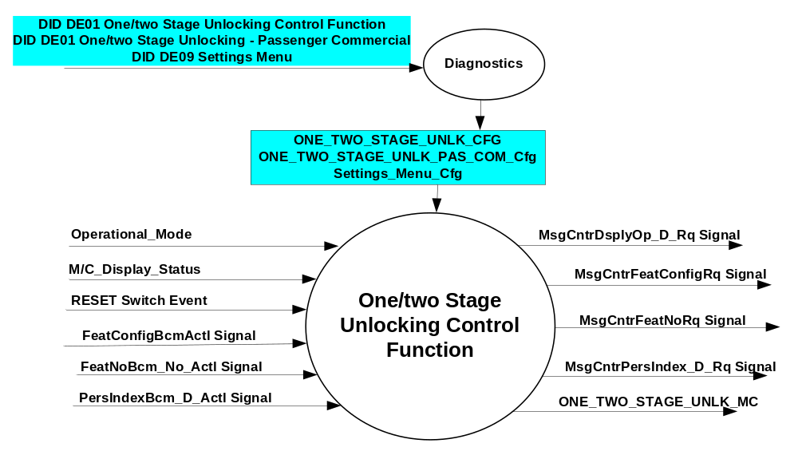

Inputs

- INTERNAL:
- Operational_Mode
- 5-button Switch Event
- ONE_TWO_STAGE_UNLK_CFG
- ONE_TWO_STAGE_UNLK_PAS_COM_Cfg
- Settings_Menu_Cfg
- M/C_Display_Status
- MUX message on the CAN Bus from BCM

- FeatConfigBcmActl Signal
Signal Name | Size  (bits) | Detail | Units | Res. | Offset | State  Encoded | Min | Max
FeatConfigBcmActl | 16 | - | Undefined | 1 | 0 |  | 0  (0x0) | 65535  (0xFFFF)

- FeatNoBcm_No_Actl Signal
Signal Name | Size (bits) | Detail | Units | Res. | Offset | State Encoded | Min | Max
FeatNoBcm_No_Actl | 16 | - | Number | 1 | 0 |  | 0  (0x0) | 65535  (0xFFFF)

- PersIndexBcm_D_Actll Signal
Signal Name | Size  (bits) | Detail | Units | Res. | Offset | State Encoded | Min | Max
PersIndexBcm_D_Actl | 3 |  | SED | 1 | 0 |  | 0  (0x0) | 1  (0x7)
 |  | PERS_1 |  |  |  | 0 (0x0)
 |  | PERS_2 |  |  |  | 1 (0x1)
 |  | PERS_3 |  |  |  | 2 (0x2)
 |  | PERS_4 |  |  |  | 3 (0x3)
 |  | Vehicle |  |  |  | 4 (0x4)
 |  | Unused |  |  |  | 5(0x5)
 |  | Unused |  |  |  | 6 (0x6)
 |  | Unused |  |  |  | 7 (0x7)

Outputs
- One_Two_Stage_Unlk_MC
- MUX message on the CAN Bus

- MsgCntrDsplyOp_D_Rq Signal
Signal Name | Size (bits) | Detail | Units | Res. | Offset | State Encoded | Min | Max
MsgCntrDsplyOp_D_Rq | 3 |  | SED | 1 | 0 |  | 0  (0x0) | 1  (0x7)
 |  | NULL |  |  |  | 0 (0x0)
 |  | QUERY |  |  |  | 1 (0x1)
 |  | SET |  |  |  | 2 (0x2)
 |  | UPLOAD |  |  |  | 3 (0x3)
 |  | RESTORE |  |  |  | 4 (0x4)
 |  | COPY |  |  |  | 5(0x5)
 |  | Not used |  |  |  | 6 (0x6)
 |  | Not Used |  |  |  | 7 (0x7)
.
- MsgCntrFeatConfigRq Signal
Signal Name | Size  (bits) | Detail | Units | Res. | Offset | State  Encoded | Min | Max
MsgCntrFeatConfigRq | 16 |  | Undefined | 1 | 0 |  | 0  (0x0) | 65535  (0xFFFF)

- MsgCntrFeatNoRq Signal
Signal Name | Size (bits) | Detail | Units | Res. | Offset | State Encoded | Min | Max
MsgCntrFeatNoRq | 16 |  | Number | 1 | 0 |  | 0  (0x0) | 65535  (0xFFFF)

- MsgCntrPersIndex_D_Rq Signal
Signal Name | Size (bits) | Detail | Units | Res. | Offset | State Encoded | Min | Max
MsgCntrPersIndex_D_Rq | 3 |  | SED | 1 | 0 |  | 0  (0x0) | 1  (0x7)
 |  | PERS_1 |  |  |  | 0 (0x0)
 |  | PERS_2 |  |  |  | 1 (0x1)
 |  | PERS_3 |  |  |  | 2 (0x2)
 |  | PERS_4 |  |  |  | 3 (0x3)
 |  | Vehicle |  |  |  | 4 (0x4)
 |  | Not Used |  |  |  | 5(0x5)
 |  | Not Used |  |  |  | 6 (0x6)
 |  | Not Used |  |  |  | 7 (0x7)

Function/Performance

Operational Modes

Mode | Differentiating Vehicle Conditions
Sleep Mode | One Stage Unlock Control Function Text Message Disabled
Limiting Mode | One Stage Unlock Control Function Text Message Disabled
Normal Mode | One Stage Unlock Control Function Text Message Enabled / Disabled
Crank Mode | One Stage Unlock Control Function Text Message Enabled / Disabled

Voltage Levels

Refer to the Cluster Features table located in the Operational Modes and Voltage Range Strategies Section in this SPSS.

Human-Machine Interface

Visual

Indicator Graphics / Display Format
For High End Display (SHMI), refer to “<Program> Cluster Menu Structure.xls” and Program VAPS Model.

Note: Some menus will show “One Stage” as “All Doors”, and “Two Stage” as “Driver First” or “Driver’s Door”.

Menu level 2 | Menu level 3 | Menu level 4 |  | Menu level 5
Vehicle | Locks | T: Locks
 | Locks | Remote Unlocking |  | T: Remote Unlocking
 | Locks | Remote Unlocking | ❍ | All Doors
 | Locks | Remote Unlocking | ● | Driver's Door

Transit Commercial Vehicle Specific HMI when ONE_TWO_STAGE_UNLK_CFG = 0x1(Enabled) AND ONE_TWO_STAGE_UNLK_PAS_COM_Cfg = 0x1(Commercial):
Menu level 2 | Menu level 3 | Menu level 4 |  | Menu level 5
Vehicle | Locks | T: Locks
 | Locks | Remote Unlocking |  | T: Remote Unlocking
 | Locks | Remote Unlocking | # | Global Unlock

Indicator Color Coordinates

Reference section COLOR & ILLUMINATION REQUIREMENTS (GRAPHICS)

Indicator Characteristics

Refer to Message Center X Display_Y Button Interface Section, where X and Y are appropriate values in this document.

Audio

None

Switch Control Logic

Consumer access to the feature Control Configuration shall be as specified in the message center basic functionality display as specified in Message Center X Display_Y Button Interface Section, where X and Y are appropriate values in this document.

System Accuracy

Within a 150msec of receiving a message that results in a change of state the cluster will update the display to the proper status.

Operation: Performance and Functional

Subsystem Algorithm Flowchart / State Diagram
Figure 2: One/Two Stage Unlocking Control Diagnostic Configuration Flowcharts

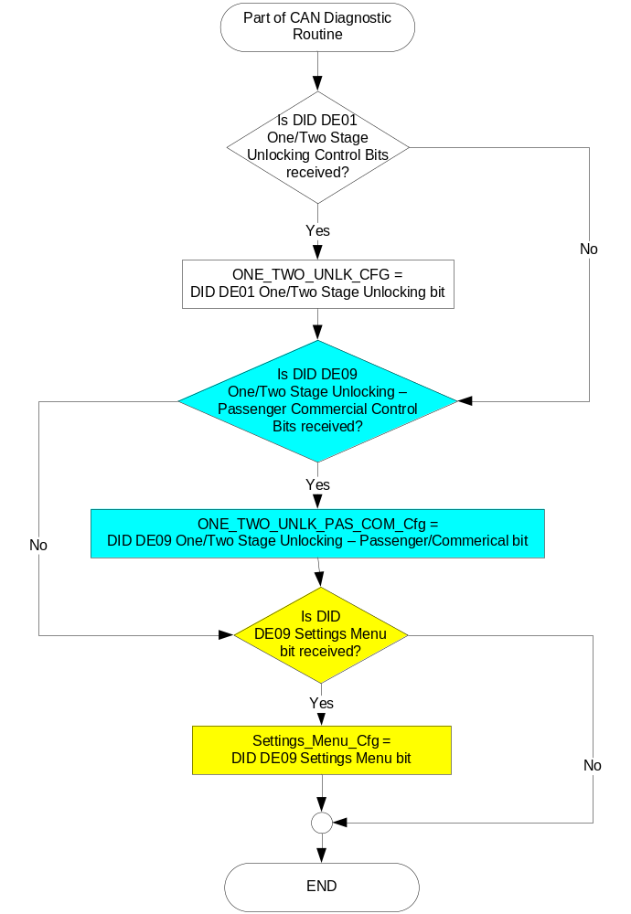

Figure 3: One/Two Stage Unlocking Control input SET request Flowcharts

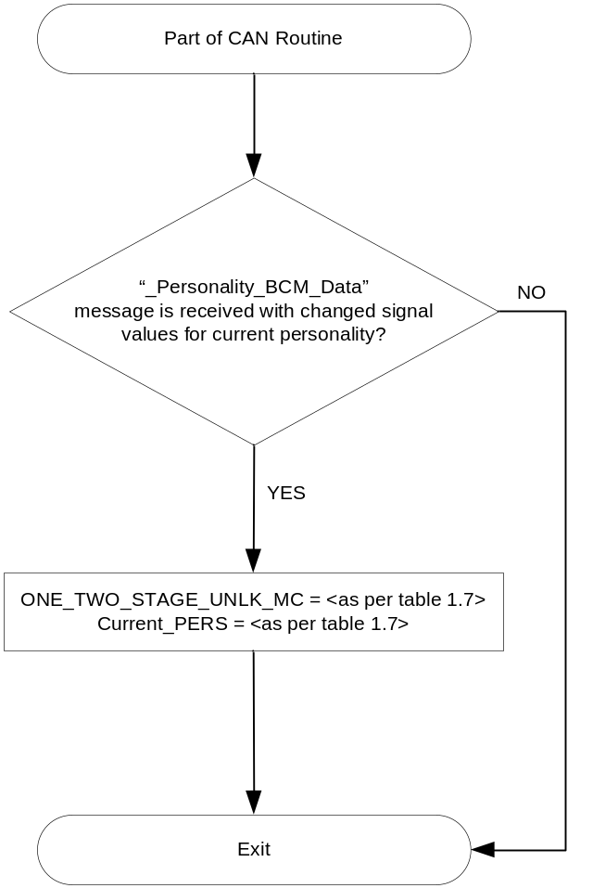

Figure 4: One/Two Stage Unlocking Control output SET request Flowchart

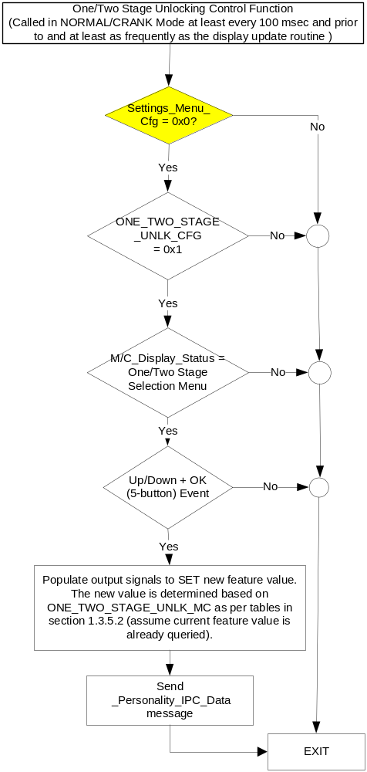

Operation Description (supports algorithm flowchart /state diagram)

- One/Two Stage Unlocking State Assignment
FeatNoRfaActl ⁽³⁾  OR  FeatNoBcm_No_Actl | FeatConfigBcmActl | PersIndexBcm_D_Actl | ONE_TWO_  STAGE_UNLK  _MC |  | Current_PERS ⁽⁴⁾
0x405 ⁽¹⁾ | 0x0000 (All Doors) | 0x0 – 0x4 |  | 0x00 | 0x0 – 0x4
0x405 ⁽¹⁾ | 0x0001 (Driver First) | 0x0 – 0x4 |  | 0x01 | 0x0 – 0x4
0x405 ⁽¹⁾ | Other ⁽²⁾ |  |  | 0x02 (Error) |  | Last Known
Missing per Section 1.4.1 ⁽²⁾ |  |  |  |  |  | Last Known
⁽¹⁾ One/Two Stage Unlocking Feature Number. Reference is Feat Num table in “Vehicle Personalization FS”
⁽²⁾ Message Response is Faulted
⁽³⁾ Equal to the received “PersIndex<--->” signal value . When faulted Keep last known value.

- SHMI Display and One/Two Stage Unlocking Request Messages

based upon ONE_TWO_STAGE_UNLK_MC
ONE_TWO_  STAGE_UNLK  _MC | Display Menu | 5-Button Switch Selection Event | MsgCntrDsplyOp_D_Rq  Signal | MsgCntrFeatNoRq  Signal | MsgCntrFeatConfigRq  Signal | MsgCntrPersIndex_D_Rq  Signal
0x00 | 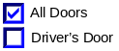 | Up/Down + OK (Select Driver First) | SET (0x2) | 0x405 | 0x0001 | Current_PERS
0x01 | 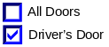 | Up/Down + OK (Select All Doors) | SET (0x2) | 0x405 | 0x0000 | Current_PERS
0x2 | 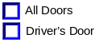 | Up/Down + OK (Select Any) | SET (0x2) | 0x405 | 0x0000 (If All Doors is selected)  0x0001 (If Driver’s Door is selected) | Current_PERS
Note: One Stage is “All Doors”. And Two Stage is “Driver’s Door.”

- SHMI Display for Commercial Transit and One/Two Stage Unlocking Request Messages based upon ONE_TWO_STAGE_UNLK_MC
ONE_TWO_  STAGE_UNLK  _MC | Display Menu | 5-Button Switch Selection Event | MsgCntrDsplyOp_D_Rq  Signal | MsgCntrFeatNoRq  Signal | MsgCntrFeatConfigRq  Signal | MsgCntrPersIndex_D_Rq  Signal
0x00 | ☑ Global Unlock On  ◻ Global Unlock Off | Up/Down + OK (Select Off) | SET (0x2) | 0x405 | 0x0001 | Current_PERS
0x01 | ◻ Global Unlock On  ☑ Global Unlock Off | Up/Down + OK (Select On) | SET (0x2) | 0x405 | 0x0000 | Current_PERS
0x2 | ◻ Global Unlock On  ◻ Global Unlock Off | Up/Down + OK (Select Any) | SET (0x2) | 0x405 | 0x0000 (If On is selected)  0x0001 (If Off is selected) | Current_PERS
Note: Display shown above is only used when ONE_TWO_STAGE_UNLK_PAS_COM_Cfg = 0x1(Commercial)

- HMI Notes for Feature 0x0405:
  - State 0x0 can be referred to as “One Stage” or “All Doors” or “Global Unlock On”.
  - State 0x1 can be referred to as “Two Stage” or “Driver First” or “Driver’s Door” or “Global Unlock Off”.

Function Safety Classification (EMC)

Class B

Memory Storage

- Function Parameters
Parameter Name | Description | Value at  Battery Connect | Value at  Wake-up
ONE_TWO_STAGE  _UNLK_MC | Output(s) displayed in the M/C | 255 (0xFF) | Do Not Init
Current_PERS | Current Personality Profile | Vehicle (0x4) | Do Not Init
MsgCntrDsplyOp_D_Rq  Signal | Output Signal to indicate Request Type. | NULL (0x0) | Do Not Init
MsgCntrFeatNoRq  Signal | Output Signal to indicate Feature Number. | (0x0000) | Do Not Init
MsgCntrFeatConfigRq  Signal | Output Signal to Specify the desired feature Value. | (0x0000) | Do Not Init
MsgCntrPersIndex_D_Rq  Signal | Output Signal to indicate which personality profile is being accessed. | PERS_1 (0x0) | Do Not Init
FeatNoBcm_No_Actl | Input signal sent from BCM to indicate Feature Number. | (0x0000) | Do Not Init
FeatConfigBcmActl | Input signal sent from BCM to indicate current value of the feature setting for the feature that is being set or queried. | (0x0000) | Do Not Init
PersIndexBcm_D_Actl | Input signal sent from BCM to indicate which personality profile is being reported. | PERS_1 (0x0) | Do Not Init
ONE_TWO_STAGE  _UNLK_CFG | State indicators for feature presence controlled via CAN at EOL at VO plant. Set to disabled at Cluster Supplier Manufacturing Plant | Use Stored Value | Use Stored Value
ONE_TWO_STAGE  _UNLK_PAS_COM_Cfg | Unique configuration bit for Transit vehicles. Transit clusters that support both commercial and passenger van configurations require this bit. It allows unique HMI for Global Unlocking. This is controlled via CAN at EOL at VO plant. Set to 0x0 “Passenger” at Cluster Supplier Manufacturing Plant | Use Stored Value | Use Stored Value
Settings_Menu_Cfg | Configures cluster to display items in the Settings menu (Set to “cluster” at cluster supplier manufacturer plant) | Use Stored Value | Use Stored Value
M/C_Display_Status | State Indicator to identify which text is currently being displayed on Message Center display. See * | See * | See*
RESET Switch Event | Event that is indicated as per the switch interface for the Message Center. See * | See * | See*
Operational_Mode | 4 state indicator for cluster operational mode | Limited | Limited, Normal or Crank
* Refer to Message Center X Display_Y Button Interface Section, where X and Y are appropriate values in this document.

Reconfigurable Telltale

Not Applicable

Prove Out

Not applicable

Message Center Msg

<None>

Error Handling

Missing Message Strategy

The signals will be declared missing as per the Diagnostics section of this SPSS.

DTCs states and history will be determined as per the Diagnostics section of this SPSS.

If ONE_TWO_STAGE_UNLK_CFG = Disabled, the cluster shall never log a missing message DTC for this feature.

Diagnostics

Self Test

None

Engineering Test Mode

Reference section “Dealer / Engineering Test Mode (ETM)”

Part II Performance

Supported Diagnostic Trouble Codes (DTCs)
DTC | Description
C14000 | Lost of Communication with CGEA_HS_BCM

DID DExx
Block  Num | Block Description | Byte(s) | Bits | State: Description | "0" | "1" | Default | Comments/  Information
PACKETED BLOCKS
$01 | Option Content (B&A) | * | * | One/Two Stage Unlocking | Disabled | Enabled | Disabled | Parameter allows the "Locks - > Unlocking -> All Doors/Driver’s Door" menu to be displayed in the cluster. If feature exists in BCM, then enable the cluster menu. This feature is standard in BCM as long as vehicle supports a remote entry key FOB. The cluster menu display can be over-ridden by the Settings Menu config.
$09 | Option Content (B&A) | * | * | One/Two Stage Unlocking – Passenger/Commercial | Passenger | Commercial | Passenger | Unique configuration applicable only for Transit. This bit applies when “One/Two Stage Unlocking” in DE01 is Enabled. It then selects between 2 possible menu displays for this item. Passenger vehicles get the standard HMI (Driver’s Door/All Doors). Commercial vehicles will get the Transit specific HMI (Global Unlock On/Off).
$09 | Option Content (B&A) | * | * | Settings Menu | Cluster | Center Stack | Cluster | This parameter allows the Settings menu to be displayed in the cluster when 0x0. When 0x1, the expectation is that settings are displayed in the Centerstack. For this feature (when 0x1), the cluster will remove almost all items from settings menu. (Cluster display choices remain). Note this is a global config, each feature still has its own config for presence on vehicle.
*Byte and bit location to be identified in Part II Specification for this cluster

Reference Specification

None

Revision History

SPSS Module Revision History

Revision Level | Name | Change Description | Date
1.0 | V. Patel | Updated for CGEA 1.3 based on CGEA STSS v2.0  Section 1.2.2 – Removed table referencing the HS-CAN message that contains the input signal.  Section 1.2.3 – Removed table referencing the HS-CAN message that contains the output signal.  Section 1.2 – Deleted “Position” column from the input and output signal tables.  Section 1.4 – Rewritten. Deleted references of specific missing message flags and timer.  Section 1.5.3 – Deleted DTC logging criteria from the table. | 4/20/2010
2.0 | S. Watkins | The RFA module was merged into the SPDJB for CGEA 1.3. Thus, all references to the RFAM are being removed from this STSS. This includes removal of all refernces to:  FeatNoRfaActl Signal (PEPS)  FeatConfigRfaActl Signal (PEPS)  PersIndexRfa_D_Actl Signal (PEPS)  PEPS_Cfg  - Section 1.1 – Description updated to remove references to RFA  - Section 1.2.1 – Deleted Figure 1 (prior Figure 2 is now Figure 1)  - Section 1.2.2 – Deleted the 3 RFA signals  - Section 1.3.5.1 – Deleted PEPS_Cfg from Figure 2. Deleted RFA signal from Figure 3 decision diamond. Deleted 3 RFA signals from Table 1.7.  - Section 1.3.5.4 – Deleted 3 RFA signals and PEPS_Cfg from table.  - Section 1.5.3 – Deleted PEPS_Cfg from DID DE00. | 1/19/2011
2.1 | Deepa B  S. Watkins | No functional changes, only added comments:  1. Added note as per QnA IPC_FS550_MY15 #247 in section 1.3.3.2 Indicator Graphics / Display Format  2. Updated DE00 to DE01 throughout, and added configuration comment to section 1.5.3.  3. Updated Section 1.3.1 and Figure 4 to show functionality in Crank. | 10/2/2016
3.0 | S. Watkins | Starting in MY2019 with U625/U611 the Settings are migrating from the cluster to Centerstack. This STSS update is to support this effort. A configuration is added to ensure backward compatiblity.  Changes shown in yellow:  - Section 1.1 – Updated description to mention Center Stack  - Section 1.2.1, Figure 1 – Added DE09 Settings Menu  - Section 1.2.2 – Added Settings_Menu_Cfg  - Section 1.3.3.2 – Added latest HMI example  - Section 1.3.5.1, Figure 2 – Added DE09 Settings Menu  - Section 1.3.5.1, Figure 4 – Added decision box for Settings_Menu_Cfg.  - Section 1.3.5.4 – Added Settings_Menu_Cfg  - Section 1.5.3 – Added Settings Menu to DE09 | 1/15/2017
4.0 | S. Watkins | Per DI Change Control on 6/22/2017, Transit requires unique HMI for this menu item. Commercial vans will have the menu say “# Global Unlock”, whereas Passenger vans will have the standard menu of “All Doors/Driver’s Door”. Requestor was Cem Musabak with approval of Ahmet Cinar.  THIS STSS UPDATE IS SPECIFIC TO TRANSIT AND DEFINES A UNIQUE DE09 CONFIG. NO OTHER PROGRAM SHOULD NEED TO DCR THIS STSS, NOR SHOULD ANY OTHER PROGRAM HAVE TO SUPPORT THE DE09 CONFIG.  Quick Background:  Transit has unique unlock methods depending on vehicle type. Not all trim types follow the Driver only/all doors open strategy that we currently support with remote unlock feature. This update is to add EOL configuration to choose between two settings  - Power Locking menu setting (MY18 V36x) approval to update specification Cem Musabak  => From Cem/s presentation. Approved to update spec. timing will need to be investigated on when this can be incorporated.  Changes highlighted in blue:  - Section 1.1 – Update description  - Section 1.2.1 and 1.2.2 – Added new config for passenger/commercial  - Section 1.3.3.2 – Added new unique HMI for Transit  - Section 1.3.5.1 – Figure 2, Added new config for passenger/commercial.  - Section 1.3.5.2 – Table 1.8 – Modified Display State for latest HMI. Added new Table 1.9 with Commercial Transit unique HMI.  - Section 1.3.5.4 – Added new config for passenger/commercial  - Section 1.5.3 – Added new config for passenger/commercial | 6/30/2017

